Nicholas Lichtsinn

Week 4 Lab

4/29/2021

Case Study 2: More Bikes

OrderItem(*Order Num,* Line, Item Number, Description, Qty Ordered, Price Each)

Answer:

OrderItem (*Order Num*, Line, *Item Number,* Qty Ordered)

Item Information (Item Number, Description, Price Each)

Case Study 3: Books Again

1. Access screenshot below.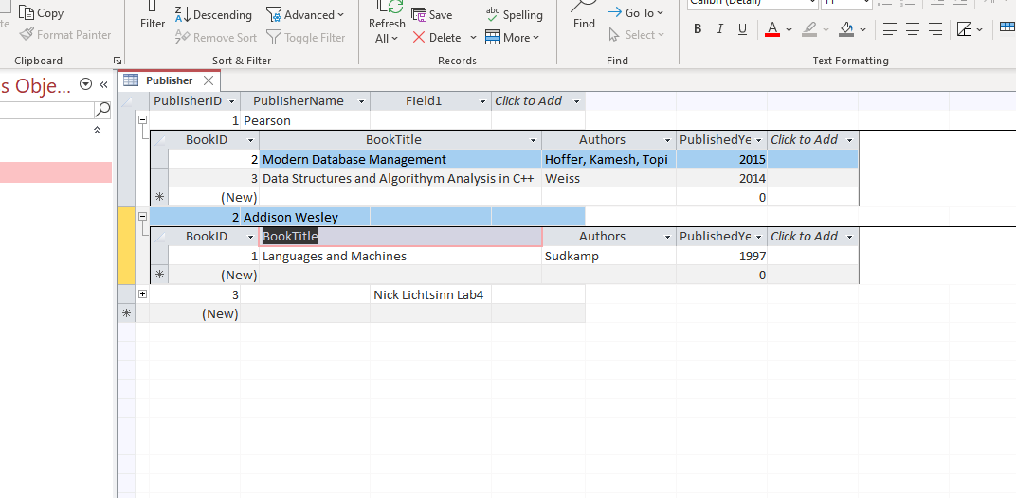
2. The ‘Book’ table is in 0NF currently because there are multivalued attributes. To get this table into 3NF we would have to
   1. Duplicate each book title for each author Hoffer, Kamesh and Topi.
   2. Remove any partial functional dependencies, so using the same notation as case study 2 we would end up with:

Book (*BookID*, BookTitle, PublishedYear, *PublisherName)*

Author (AuthorID, Authors, BookTitle)

* 1. At this point we are in 3NF because there are no TFDs

Part 2: Normalizing Video Data for VidCast

Starting:

VideoData (VideoID, Video Title, User Name, User Tier, Min Tier Followers, Stream Start, Video Duration (mins), Content Rating, Rating Description)

3NF:

VideoData(*VideoID*, *User Name*, *Content Rating*)

UserData(User Name, User Tier, Min Tier Followers)

VideoInfo(VideoID, Video Title, Stream Start, Video Duration (mins), Content Rating)

ContentInfo(Content Rating, Rating Description)